

**Faculty of Science and Technology**

**CISC3014 Information Retrieval and WebSearch**

**Verbaviva: A Vocabulary Study System**

DC127368 HUANG CHUYUE

DC126769 SONG XUEQING

# **Table of Contents**

**Table of Contents 2**

**1. Introduction 3**

1.1 Background 3

1.2 Motivation 4

1.3 System components 4

**2. Recommendation System 6**

2.1 Reading text 6

2.2 Tokenization 6

2.3 Compute tf-idf 7

2.4 Calculate cosine similarity 8

2.5 Ranking 9

**3. User Interface 10**

3.1 High-level Architecture 10

3.2 Workflow 11

**4. Data analysis ,reflection and future plan 14**

4.1 Data Analysis 14

4.2 Interview & reflection 15

4.3 Future Plan 16

**5. Reference 17**

# 

# 

# 

# 

# 

# 

# 

# 

# **1. Introduction**

As we deeply understand the challenges that students face when studying abroad, particularly in adapting to new environments, it is important that students have the opportunity to learn how to communicate effectively in daily life. Meanwhile, in order for learners to learn the vocabulary for the scenes they need in a shorter period of time in a more targeted manner, we have launched a website that combines a recommendation system with traditional vocabulary memorization features to assist students in mastering foreign languages efficiently.

Therefore, we have developed a platform that not only prioritizes high-frequency conversations and language usage but also utilizes personalized recommendations to enhance the learning experience.

## 1.1 Background

Studying abroad offers incredible opportunities for personal and academic growth. However, language barriers can often hinder students from fully immersing themselves in their host country's culture and society. To address this challenge, our website leverages the potential of recommendation algorithms to provide students with targeted vocabulary learning resources based on their specific needs and interests.

## 1.2 Motivation

Our primary goal is to empower students to confidently navigate daily life during their overseas studies through the acquisition of practical language skills. By focusing on high-frequency vocabularies and language usage, we aim to equip students with the vocabulary they need to communicate fluently in common scenarios. Through personalized recommendations based on their ratings, we strive to optimize the learning process, making it more efficient, engaging, and effective.

## 1.3 System components

1.3.1 Datasets

We summarized and synthesized eight large common scenarios, and each main category will be subdivided into 2-4 small scenarios, which are as follows.

* Academic Research Scenarios
* Essay Writing
* Learning Experience Communication
* Accommodation Scenarios
* Furniture and Appliance
* Room
* Banking Service Scenarios
* Accounts
* Finance
* Extracurricular Scenarios
* Competitions
* Sports
* Learning Scenarios
* Assessment Methods
* Course Structures
* Course Types
* Specialized Subjects
* Library Scenarios
* Book Categories
* Borrowing and Returning Books
* Equipment and Features
* New Student Enrollment Scenarios
* Campus Facilities
* Educational Background
* Faculty and Staff
* Identity
* Outing Scenarios
* Accommodation and Transportation
* Airports
* Carring items
* Vacation Attractions

Form of datasets:

**one word / phrase (Chinese meaning)**

**example sentence**

For example:

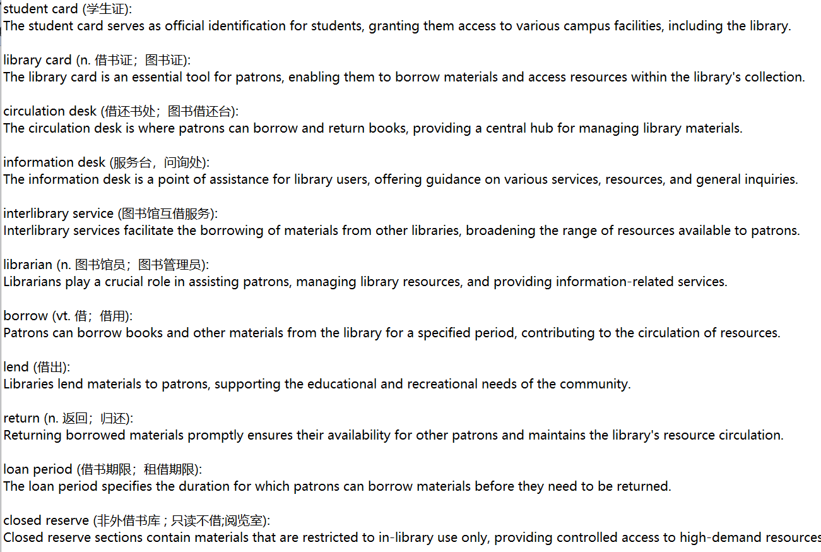

1.3.2 Principles of operation

a. After logging into the webpage, the user selects a category according to his/her preference, and the system randomly assigns a subcategory(not visible to users) of the chosen category, from which 10 words are randomly selected for the first round of vocabulary learning.

b. After the user completes the first round of learning, the user scores 1-5 points for the satisfaction of the current round of word recommendation, and the system recommends the next round of scenes according to the user's scoring and starts the second round of word learning.

c. Users continue to learn the second round of words, and score the round of word recommendation satisfaction level of 1-5 points, the system recommend next subcategory according to the user's scoring.

d. Repeat the third step until four rounds of word learning is complete.

This part will be illustrated in detail in 3.1.

# **2. Recommendation System**

## 2.1 Reading text

We read all the documents from datasets.

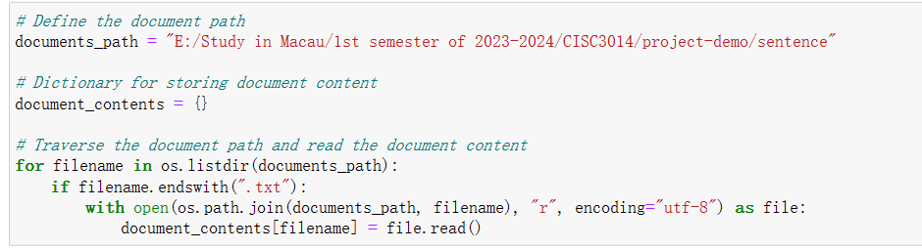

## 2.2 Tokenization

Since the database contains some characters and lexical interpretations, we need to remove them before using the tf-idf algorithm in order to produce more accurate results in the subsequent recommendation algorithm.

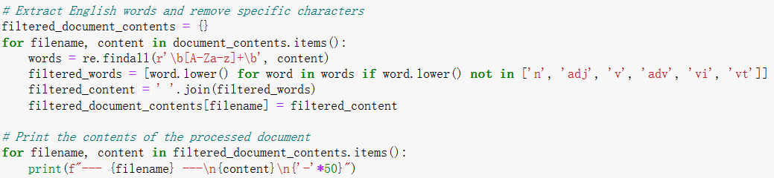

The result is shown below.

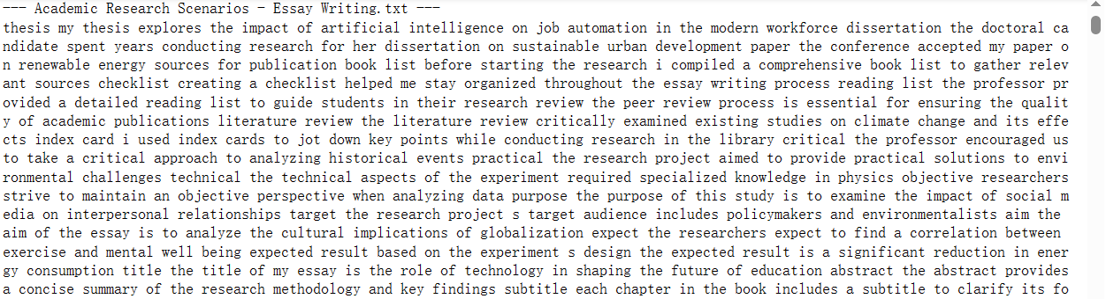

## 2.3 Compute tf-idf

(1) TF-IDF (term frequency-inverse document frequency) is a statistical measure that evaluates how relevant a word is to a document in a collection of documents.

(2) TF-IDF for a word in a document is calculated by multiplying two different metrics:

* The term frequency of a word in a document. There are several ways of calculating this frequency, with the simplest being a raw count of instances a word appears in a document. Then, there are ways to adjust the frequency, by length of a document, or by the raw frequency of the most frequent word in a document.
* The inverse document frequency of the word across a set of documents. This means, how common or rare a word is in the entire document set. The closer it is to 0, the more common a word is. This metric can be calculated by taking the total number of documents, dividing it by the number of documents that contain a word, and calculating the logarithm.

(3) Formula

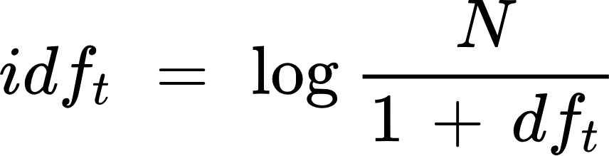



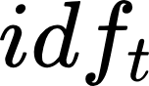: Inverse document frequency of term t

N: total number of documents

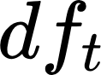: total number of documents the term t is in

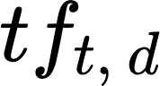: term frequency of term t in document d

(4) Code display

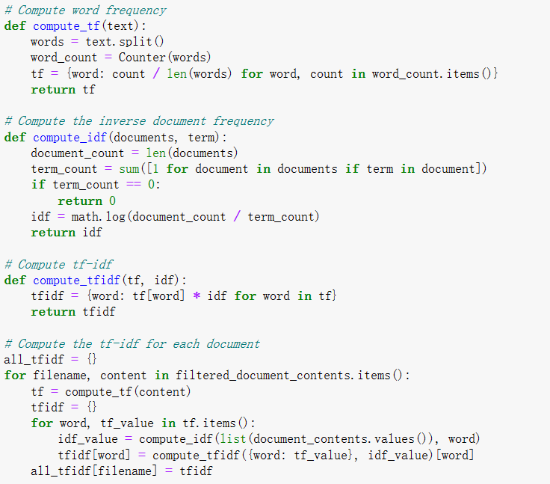

## 2.4 Calculate cosine similarity

(1) In data analysis, cosine similarity is a measure of similarity between two non-zero vectors defined in an inner product space. Cosine similarity is the cosine of the angle between the vectors; that is, it is the dot product of the vectors divided by the product of their lengths.

The cosine of two non-zero vectors can be derived by using the Euclidean dot product formula:

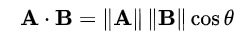

Given two n-dimensional vectors of attributes, A and B, the cosine similarity, cos(θ), is represented using a dot product and magnitude as

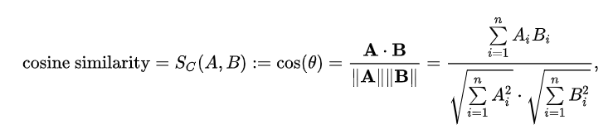

(2) Cosine similarity is a metric, helpful in determining how similar the documents are. A document of a specific scenario can be represented by thousands of attributes, each recording the frequency of a particular word (such as a keyword) or phrase in the document. Thus, each document is an object represented by what is called a term-frequency vector.

We can measure the similarity between two scenarios in Python using Cosine Similarity.

We take the scenario “Academic Research Scenarios - Essay Writing '' as an example, calculate the cosine similarity of it with the other scenarios.

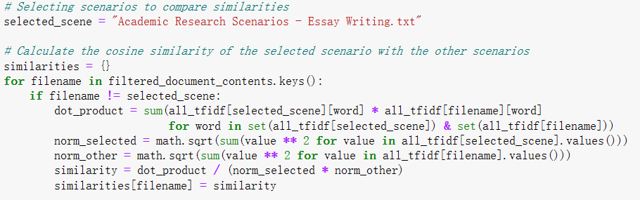

## 2.5 Ranking

Finally, we sort the similarity from high to low to facilitate the subsequent operation, i.e., the system recommends the next round of scenario word selection for the user.

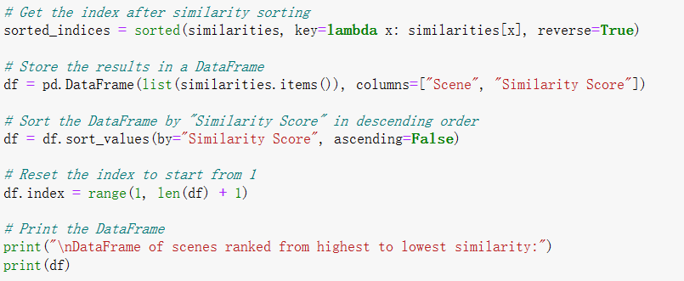

The ranking result is as follows.

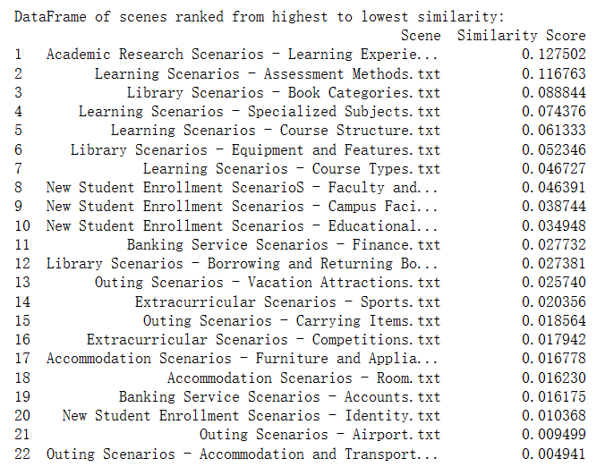

The similarity plot is shown below(similarity plots for all 23 files will be shown in appendix A).

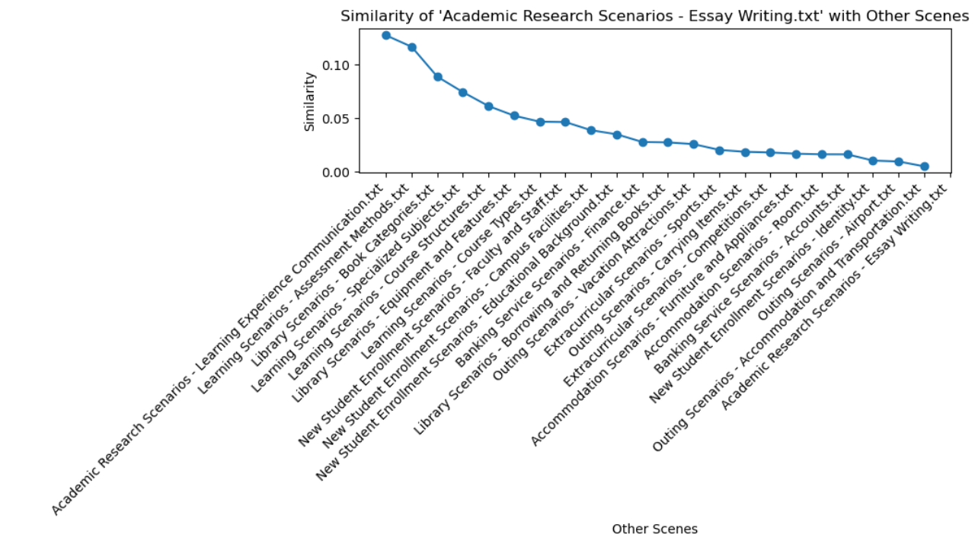

# **3. User Interface**

## 3.1 High-level Architecture

The implementation of the system consists of frontend, files and API(as shown in figure 3.1). Files contains two parts: user accounts and dataset are in .json format, which can be fetched directly by javascript. Although in practice data must not be connected directly to the front-end as this can lead to leakage of user information and data.

In order to simplify the development process and because the system is for demonstration purposes only, we have treated it as such. In this case, the account number and password are generated automatically, thus providing the easiest way to secure the user. For 2-dimensional data that are not suitable to store in .json format(e.g., matrices), we use flask framework in python to design APIs for extracting and saving data. We put this kind of data into .xlsx and process such data using Dataframe.

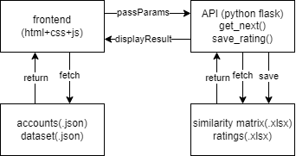

Figure 3.1 High-level Architecture of Verbaviva

## 3.2 Workflow

Step 1: open url: <https://angiesong.pythonanywhere.com/static/login.html> , users can see login page like this:

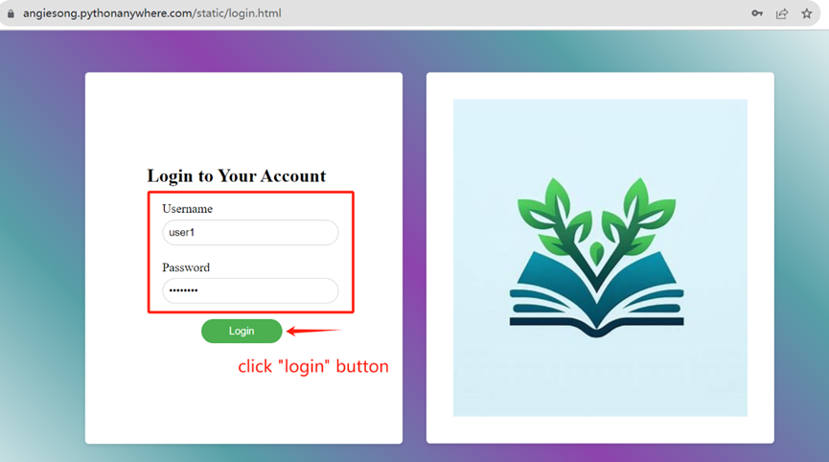

Figure 3.2.1 Login Page

Users input the given username and password, if they are correctly inputed, they can login page,otherwise they need to check whether their spelling is correct(be careful with one“1”, lowercase L”l” and “I” in password, in the most updated version, there is a “show password” checkbox to address this issue)

Step 2: Here users can choose their favorite category among the 8 categories displayed on webpage.

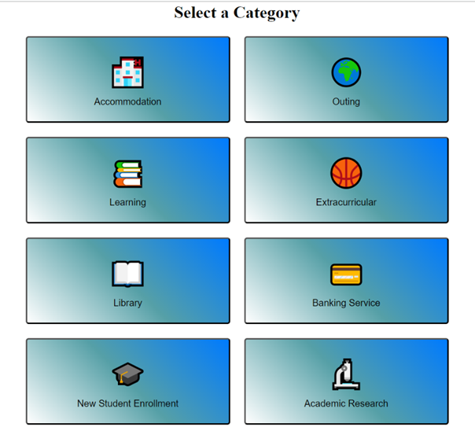

Figure 3.2.2 Select a Category

Step 3: Users will be assigned 10 words in the first list which is extracted from one of the randon subcategories from the chosen category. When user finished learning of a certain word, he/she need to mark it by clicking the checkbox on the right. As during the data collection period, a lot of people complained about the size of the clickboxes is too small, the most updated version is now much more noticeable.

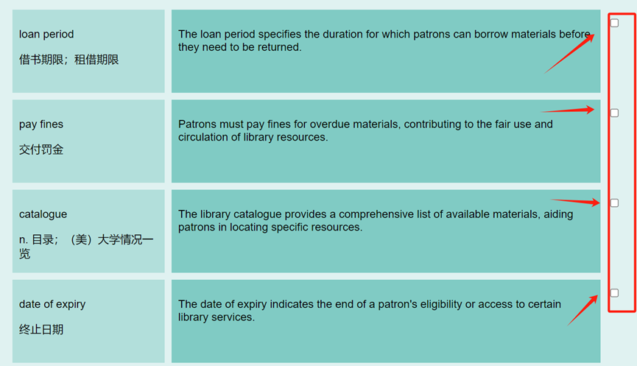

Figure 3.2.3 Word Learning

Step 4: After all the 10 checkboxes are checked, a rating form will pop out. Based on the current round, users can rate for current scenario, if they scored high, they will still get similar scenarios, otherwise they will receive dissimilar recommendation.

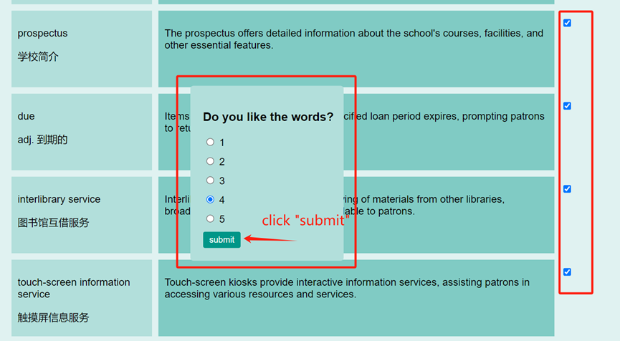

Figure 3.2.4 Rating

Step5: Step3-4 will be repeated until four rounds finished, after finished, the finish webpage will be shown on the screen.

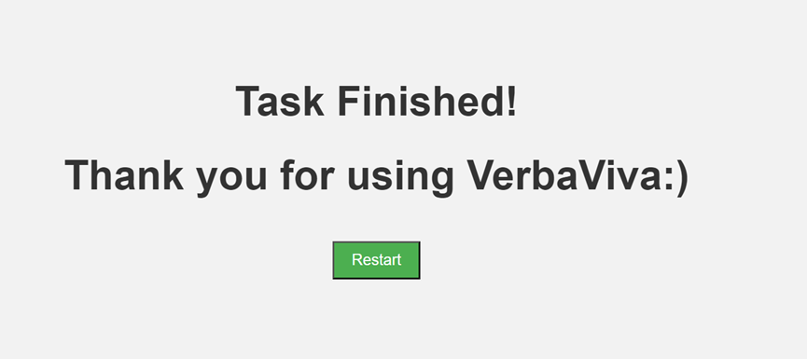

Figure 3.2.5 Task Finished Page

Below is the activity diagram of the system workflow.

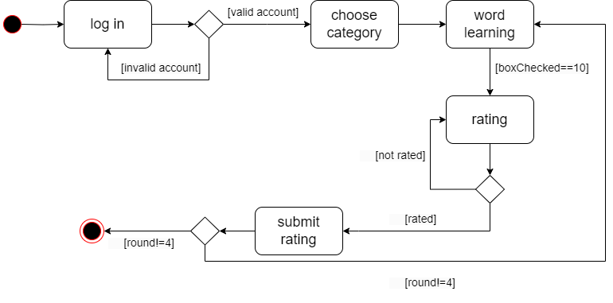

Figure 3.2.6 Activity Diagram of User Workflow

# **4. Data analysis ,reflection and future plan**

## 4.1 Data Analysis

After recruited 30 students from different majors and different English background, the raw data is shown below:

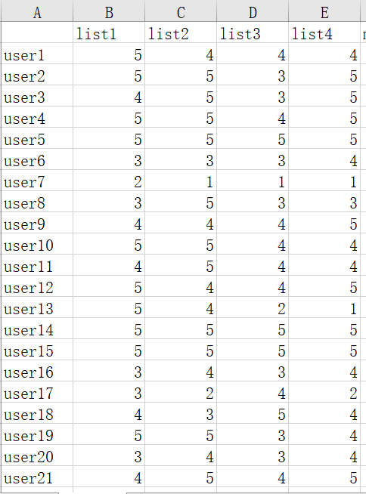 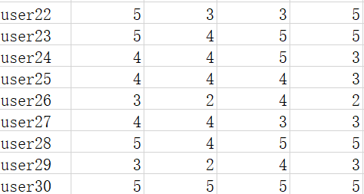

Figure 4.1.1 Raw Data

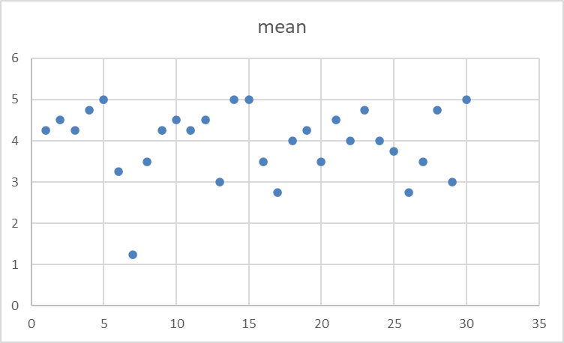

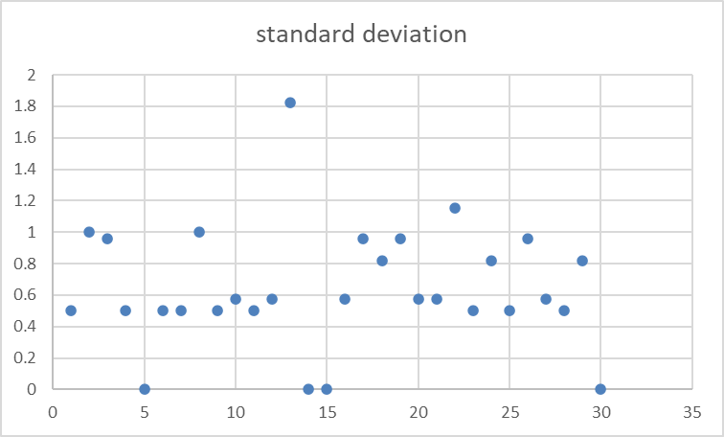

We can see that most of users feel overall satisfied on the system, yet as the rating result is not positively correlated with satisfaction, we decide to interview on both normal data and outliers.

## 4.2 Interview & reflection

After the interview of every user, we gained some insights, we will analyze them based on dataset, recommendation algorithm and user interface.

Insight1: Most of students think the dataset is relatively easy and not that practical in real-life environments.

Reasons:

(1)As the dataset is originated in IELTS practice vocabulary, students already passed IELTS or equivalent level exams may find the words are easy, they tried to obtain some harder words by decreasing the rates. As the recommendation is only for recommending context, the level of words will not change.

(2) As the words are generally from exam based lists, although at the beginning we thought of IELTS exam as a relatively practical exam, yet it does not meet the lack of real-life environments of Chinese people.

(3) Yet some users found that the Chinese meaning below the words are quite eye-catching, seducing them to look at the meaning rather than the sentence first, thus they ended up with some boring words instead of grasping the whole context of word usage, they also suggest we hide the Chinese meaning first and treat the checkbox as a trigger to display the word meaning.

Insight2: Most students like the similarity recommendation when they want to continue to study similar topics, yet when they want to try something different, the system recommend them things too different, resulting they continue to give low marks.

(1)We can see the similarity plot from Appendix A, the descent rate of different similarity line varies. This may due to the number of subcategories in different categories varying from 2-4, and that the number of words in each subcategory file also varies, Which also decrease user satisfaction.

(2)The algorithm design is relative a rigid one that may encounter “recommendation loop” when user want something dissimilar, as the similarity matrix is by define symmetric. When user select “1” twice, the user may get back to the same subcategory, while the user may just mean “ I want something other than these two”.

Insight3: Users found the learning pattern a bit boring, as some people suggest, the webpage looks like “a word file”.

(1)Compared with traditional vocab systems, we need to add some interactive practice questions so that users can know how well they learned such topic.

(2) Different design is also applied in some well-known vocab study apps, which allow users to choose among several different styles. However, web design is not the focus of our system, so we will not elaborate this part further.

## 4.3 Future Plan

4.3.1 Dataset

1. The content of the dataset should be more practical in daily life. As this kind of dataset is not easy to find, such dataset should be scraped from website or extracted from existing professional databases.
2. Each category should not only be large but also be equally ditributed in size, in order to make the similarity plot smoother.

4.3.2 Implementation

(1)User profile

In order to provide more customized categories, user profile need to be created. We need to collect data for their purpose to use the website, their English level, their hobby, their long-term living environment and so on.

(2)Collaborative Filtering

As user number grows, collaborative filtering can also be considered to make a hybrid recommendation system-based vocab system, and more dynamic lists can also be created through this process, since currently we recommend solely based on whole subcategory files.

# **5. Reference**

PythonAnywhere Flask deploy: <https://tutorial.helloflask.com/deploy/>

**Appendix A**





